Game Design Document

Fill up the Following document

1. Write the title of your project.
2. What is the goal of the game?

YOU HAVE TO FOLD ALL THE CLOTHES ON THE BED AND PUT IT IN THE ALMIRAH

1. Write a brief story of your game?

IN ORDER TO GAIN POINTS AND EARN A LIVING, YOU HAVE TO FOLD ALL THE CLOTHES OF THE OWNER OF THE HOUSE YOU ARE WORKING FOR.

1. Which are the playing characters of this game?

* Playing characters are the ones which respond to the user based on the input from the user
* Cars, monkeys, dinos, wizards etc, are the playing characters in the game.

|  |  |  |
| --- | --- | --- |
| Number | Character Name | What can this character do? |
| 1 | AVATAR (PLAYER CAN DECIDE NAME OF THEIR OWN PREFERENCE) | IT FOLDS THE CLOTHES, BATTLES WITH ANTAGONIST |
| 2 | IMP (ANTAGONIST/CREATURE) | DISTURBS THE AVATAR FROM FOLDING CLOTHES |
| 3 |  |  |
| 4 |  |  |
| 5 |  |  |
| 6 |  |  |
| 7 |  |  |
| 8 |  |  |

1. Which are the Non Playing Characters of this game?

* Non Playing characters are the ones which don't have an action or a behaviour when the user interacts with the game.
* Hurdles, stones, bananas, coins, etc are non playing characters in the game.

|  |  |  |
| --- | --- | --- |
| Number | Character Name | What can this character do? |
| 1 | ALMIRAH | ITS WHERE YOU PUT THE CLOTHES |
| 2 | BED | ITS WHERE THE UNFOLDED CLOTHES ARE |
| 3 | IMP SPRAY | A WEAPON AGAINST IMP |
| 4 | CLOTHES | THE POINT GAINING ELEMENT |
| 5 | IMP SHIELD | PROTECTS AVATAR |
| 6 |  |  |
| 7 |  |  |
| 8 |  |  |

Draw your imagination of this game. What does this game look like?

* Draw the game either on your computer or on paper,
* Add images of scenes of the game to show each of the playing and non-playing characters at least once.

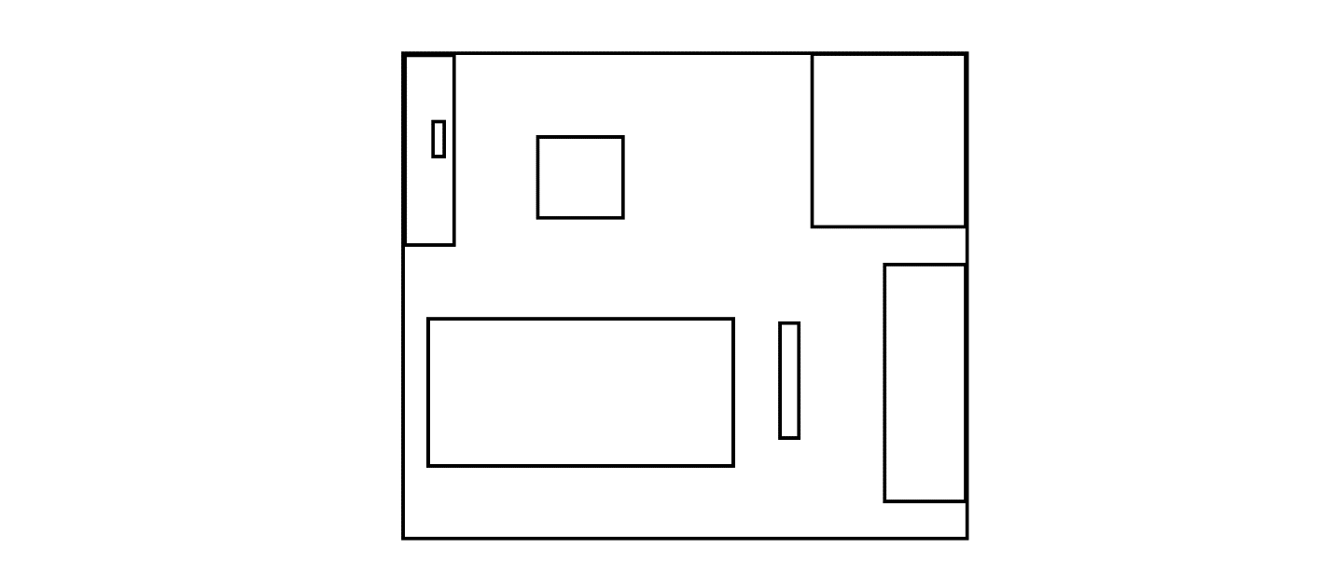

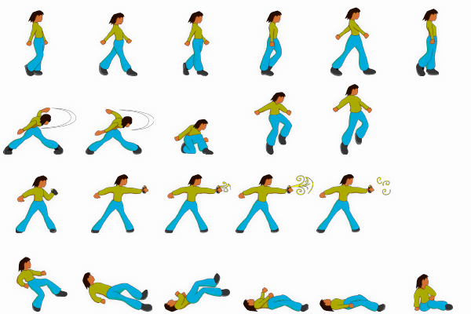

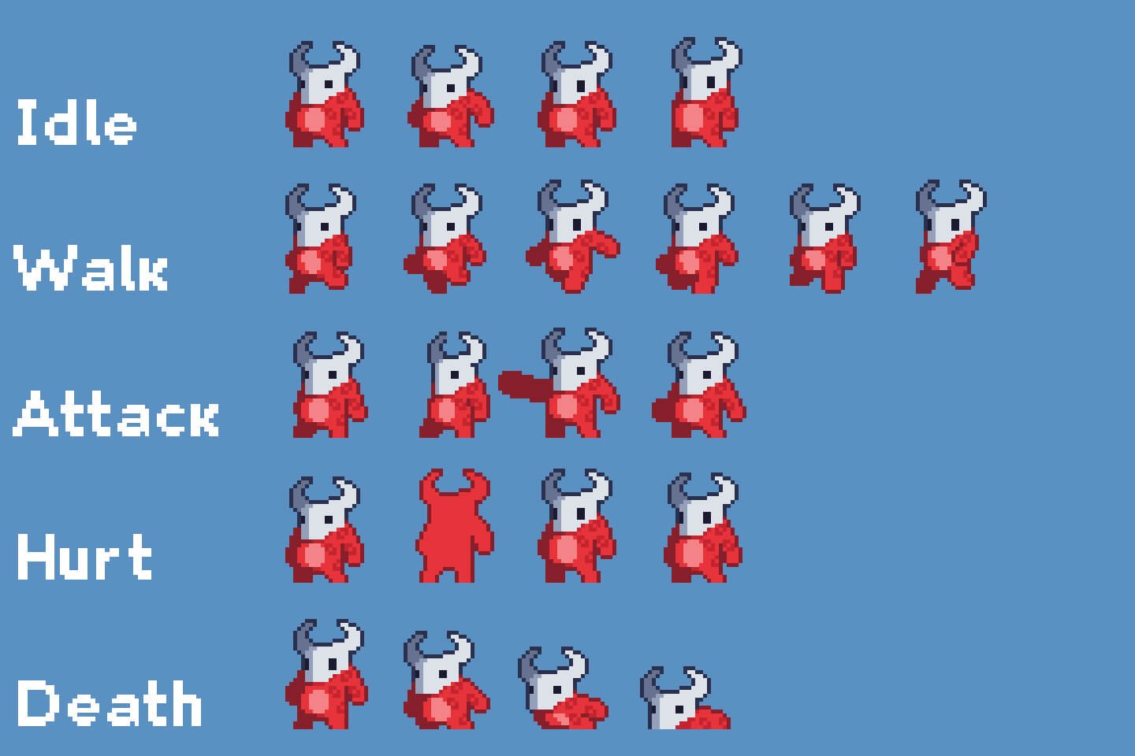

How do you plan to make your game engaging?

AS THE LEVELS INCREASE :-

THE TIME LIMIT DECREASES

THE CLOTHES ARE KEPT FARTHER AND FARTHER IN THE BED

THE IMP APPEARS MORE OFTEN

YOUR POWERUPS STILL COME AT THE SAME PACE AND ARE SLIGHTLY STRONGER (TO KEEP THE BALANCE MANTAINED)

[AS A WHOLE, THE PRESSURE ON THE PLAYER/AVATAR INCREASES]

CHANCE:

THE IMP GETS DEFEATED IN ONE ROUND ITSELF

YOU GET A SECONDS INCREASER POWER UP AND INCREASE YOUR TIME LIMIT

YOU GET DOUBLE IMP SPRAY DURING THE GAME

SKILL:

FIGHTING THE IMP

FOLDING THE CLOTHES BY MOVING THE AVATAR BACK AND FORTH SMOOTHLY

USING THE POWERUPS

RULES:

SPACE KEY MAKES CLOTHES FOLD

1 POINT FOR EVERY 3 CLOTHES FOLDED

2 POINTS REDUCED FOR 1 CLOTH IF IMP UNFOLDS IT

GAIN ADDITIONAL 20 POINTS ON COMPLETING OBJECTIVE/GOAL

NO BONUS POINTS IF GAME OVER

ON REFOLDING, THE CLOTH SPLITS INTO 2 MORE

POWERUPS:

SECONDS INCREASER(CHANCE)

IMP SPRAY (20 CONSECUTIVE CLOTHES, HURTS IMP IN ONE SPRAY, KILLS IMP 3 SPRAYS, STAYS FOR 10 SECONDS)

IMP SHIELD (25 CONSECUTIVE CLOTHES, WORKS FOR 12 SECONDS)

DOUBLE IMP SPRAY (SAME LIKE PREVIOUS IMP SPRAY BUT WORKS FOR 12 SECONDS)

IMP STRIKE (STRIKE IMP, FATAL IN 2 BLOWS, ENABLED FOR 6 SECONDS)